**Course Content Creation Module Documentation**

**Purpose**

To facilitate the organization and delivery of educational content to learners.

**Usage**

**How to add course content**

1. Log in as an administrator or teacher and go into your course
2. Toggle Edit mode top right
3. To add files such as documents or presentations, drag and drop from your desktop
4. To add other activities, click the link **Add an activity or resource** wherever you want to add it:
5. Choose an item and double click to add it.

**How to add course content for specific groups**

Log

1. **Create Groups**: You can create groups in your course by selecting the **Groups** option in the Participants drop-down menu.
2. **Create Groupings**:

**What is a grouping?**

A grouping is a collection of groups within a course. Using groupings allows you to direct tasks at one or more groups in your course, so that they can work together on the tasks.

To add a new grouping, select the ***Groupings*** option in the ***Participants*** drop-down inside a course and select ***Create grouping***.

Add a ***Grouping name*** and, optionally, a ***Grouping ID number*** to and ***Grouping description***. The optional grouping ID number may be added for matching the grouping against external systems or when when [importing groups into groupings](https://docs.moodle.org/403/en/Import_groups). Grouping ID numbers are not displayed anywhere on the site. Within a course, all grouping ID numbers must be unique.

1. **Add Groups to a Grouping**: You can add groups to a grouping by clicking the “Show groups in grouping” icon in the edit column.
2. **Selecting a grouping for an activity:**

To use a particular grouping in an activity:

1. Click the 'Edit settings' link for the activity
2. In the Common module settings section, set a group mode
3. Select the grouping from the grouping dropdown menu.
4. Click the "Save changes" button at the bottom of the page.

If the group mode is set to separate groups, students will only see the activities they have been assigned to. Teachers will see the name of the grouping in brackets after the activity name on the course page. A count of activities assigned to each grouping is kept on the groupings page.

Please note that the grouping option appears by default only in activities that support group modes.

1. **Restricting an activity, resource or course topic to a grouping**

To be able to restrict an activity, resource or course topic to a grouping, [Restrict access](https://docs.moodle.org/403/en/Restrict_access) must be enabled. This will result in a 'Restrict access' section in the activity, resource or topic settings and a grouping restriction can then be added.

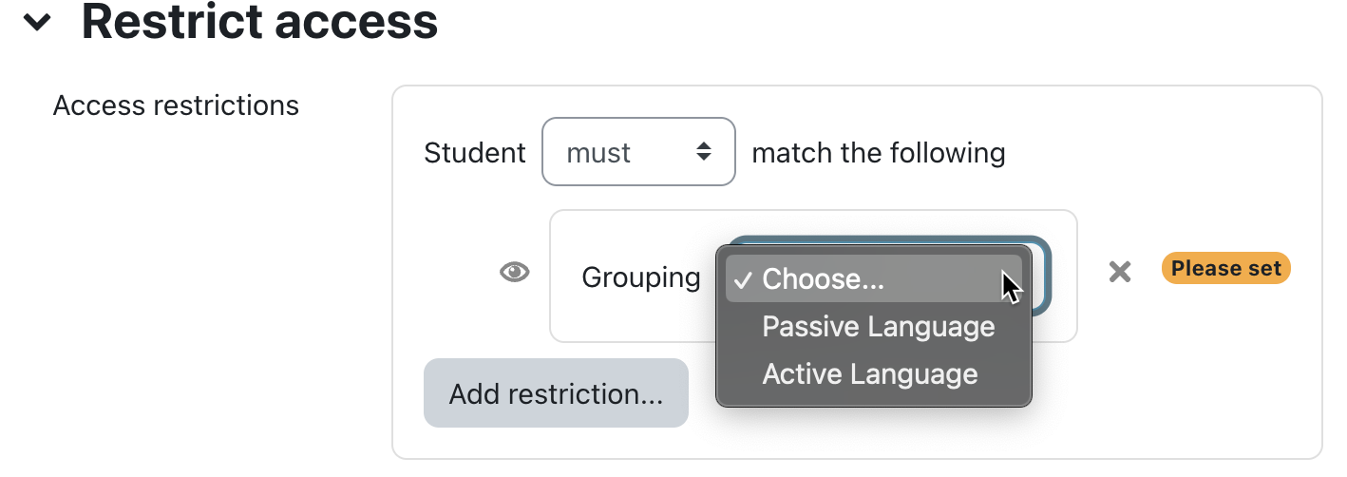

Ensure that the ***Restriction by grouping*** option is enabled in the [Restrict access settings](https://docs.moodle.org/403/en/Restrict_access_settings); otherwise the ***Grouping*** button is not shown in your list of available restrictions.